**ONLINE COURSE PORTAL SYSTEM**

**Abstract:**

The Online Course Portal System is a comprehensive, web-based platform designed to streamline digital learning for students and professionals. It offers secure login, user-specific dashboards, structured course management, and access to interactive content such as video lectures, quizzes, and assignments. Students can monitor their learning progress, receive feedback, and engage in discussions with peers and instructors. Instructors are equipped with tools to upload content, create assessments, and manage student performance efficiently. The system includes an admin panel for overseeing users, content, and platform operations.

A key innovation is Course Portfolio Integration, which allows users to build a dynamic digital portfolio showcasing completed courses, projects, and earned skills. This portfolio is automatically generated from the backend SQL database, ensuring authenticity and making tampering extremely difficult. Another standout feature is Proof-of-Knowledge Certificates. Instead of issuing static certificates, the system requires users to periodically pass assessments to keep their certification active. If a user fails, the certificate is temporarily invalid until they successfully retake the test.

These advanced features enhance the credibility and long-term value of online education by encouraging continuous learning and offering a verifiable, skills-based record of achievement that can be shared with employers, institutions, or professional networks.

**Keywords:**

E-learning, Course Management, Student Dashboard Online Assessment, Video Lectures, Progress Tracking, Assignment Submission, Payment Integration, Badges system, Course portfolio integration.

**Traditional Systems:**

1.Relies heavily on physical infrastructure and rigid schedules.

2.Learning is confined to classrooms, requiring in-person attendance.

3.Course materials are distributed in hard copy, making updates difficult.

4.Limited access to learning materials outside the classroom.

5.Assessment and feedback are slow and lack transparency.

6.Delays in tracking performance and making improvements.

7.Not inclusive for remote learners, working professionals, or students with disabilities.

8.Poor scalability during emergencies like pandemics.

9.Static, time-bound, and inflexible in today’s digital era

**Purposed System:**

1.A digital platform that overcomes the limitations of traditional education.

2.Enables flexible, accessible, and personalized learning anytime, anywhere.

3.Features two user roles: Student and Instructor, each with a dedicated dashboard.

4.Instructors can create and manage courses with multimedia, assignments, and assessments.

5.Students can enroll, access content, complete tasks, and receive instant feedback.

6.Includes real-time progress tracking and built-in communication tools.

7.Structured yet adaptable course flow for a dynamic learning experience.

8.Scalable to accommodate large audiences without performance loss.

9.Emphasizes automation, interactivity, and data-driven feedback.

10.Designed for remote accessibility and future-ready education.

**Related Applications**

|  |  |  |
| --- | --- | --- |
| **Applications** | **Advantages** | **Disadvantages** |
| **Coursera** | 1. Offers high-quality courses from prestigious universities (e.g., Stanford, Yale, University of Michigan).  2. Provides professional certificates and even full degrees in subjects like business, computer science, and humanities. | 1. Professional certificates and degrees can be expensive, especially for those pursuing full degrees.  2. While many courses are free to audit, you often have to pay to get a certificate or access full features.  3. Some courses may have a heavy time commitment, which could be difficult for learners with busy schedules. |
| **edX** | 1. Offers a wide range of high-quality courses from top universities like Harvard, MIT, and Berkeley.  2. Allows students to audit courses for free, with the option to pay for a certificate.  3. Provides professional certifications, MicroMasters programs, and even full university degrees.  4. Courses span various subjects, including tech, business, and humanities. | 1. While auditing is free, certificates, professional programs, and degrees can be expensive.  2. The quality of certain courses may vary, especially those not directly managed by the university.  3. Some programs can be very time-consuming, especially for degrees and certifications that have a structured timeline. |
| **Udemy** | 1. Offers a huge variety of courses, from programming and design to business, marketing, and personal development.2. Frequently offers significant discounts, making courses very affordable.  3. Lifetime access to purchased courses, so you can revisit material anytime.  4. Self-paced learning, which allows flexibility in how you manage your learning schedule. | 1. Courses are not accredited or recognized by formal institutions, so certificates have limited professional value.  2. Course quality can vary widely since anyone can create a course, so you may encounter poorly structured or shallow content.  3. With thousands of courses, it can be difficult to find high-quality ones without proper filtering or review. |
| **Skillshare** | 1. Focuses on creative skills such as design, photography, writing, business, and marketing.  2. Offers project-based learning, allowing students to create tangible work.  3. Membership grants access to all courses, which is great for exploring multiple topics.  4. Provides a community aspect with feedback from instructors and peers. | 1. No formal certificates or degrees are provided, so it’s not suitable for those seeking professional credentials.  2. Course quality can vary, and many instructors may lack the same academic rigor as those on other platforms.  3. Requires a subscription for full access to all courses, which could be limiting for those seeking a single course. |
| **Khan Academy** | 1. Completely free access to courses, making it highly accessible to anyone.  2. Excellent for K-12 education, with an emphasis on subjects like math, science, history, and arts.  3. Provides interactive features, including practice exercises, quizzes, and video lessons that help reinforce learning.  4. Ideal for students who prefer learning at their own pace and need additional support with school subjects. | 1. Focuses primarily on K-12 content and does not offer advanced university-level or specialized courses.  2. Lacks formal certification or degree programs, which may be a disadvantage for those seeking credentials for job advancement.  3. Limited social interaction opportunities (no peer review or instructor feedback like in other platforms). |

**PROPOSED SOLUTION: -**

**STUDENT LOGIN MODULE**

**1. Course Recommendation System**

A smart, AI-powered feature tailored to personalize the student's learning journey.

Features:

* Interests/Skills (Onboarding Questionnaire): At the time of account creation or profile updates, students complete a questionnaire indicating their interests (e.g., data science, design) and skills (e.g., coding, writing). These preferences feed into the recommendation logic.
* Previous Course History: The system analyzes both completed and currently enrolled courses to recommend relevant learning paths that align with the learner’s academic and professional goals. The system analyzes both completed and currently enrolled courses to recommend relevant options that align with the learner’s learning goals. Recommendations are also based on the student’s college courses to ensure relevance and continuity.
* Performance Metrics: Tracks performance (e.g., quiz scores, assignment quality) to suggest courses that match a student’s strengths or help improve weaknesses.
* Dynamic Suggestions: As performance and preferences evolve, the recommendations update in real-time to ensure ongoing relevance**.**

**2. Graphical Representation (Progress Tracker)**

An interactive dashboard visualizing progress for better self-monitoring.

Features:

* Module-wise Progress: Displays completion status for each module (e.g., Module 1 – 70%, Module 2 – 40%).
* Assignment Completion: Shows a summary of submitted, pending, and overdue assignments.
* Quiz Scores: Visualizes performance across all quizzes to help students track their improvement.
* Overall Course Completion: A cumulative progress bar showing how much of the course is completed in percentage.

**3. Student Assignment Management**

An intuitive portal for handling coursework seamlessly.

Features:

* Upload/Download Assignments: Students can upload their work in various formats (PDF, DOCX, ZIP) and download guidelines.
* View Submission Deadlines: A integration highlights upcoming and overdue assignments.
* Track Submitted/Pending Assignments: Color-coded tags or a status column helps students know what’s pending or submitted.
* Feedback and Grades: View instructor feedback and scores per assignment.

**4. Online Query Sessions**

A support-oriented communication feature.

Features:

* Chat or Forum-Based Q&A: Students can post questions in a discussion forum or use a live chat function to ask instructors or peers.
* Schedule Live Support Sessions: Book one-on-one help sessions or join group sessions based on instructor availability.
* Tag-Based Question Sorting: Questions can be categorized (e.g., Module 2, Topic: Algorithms) for easy navigation and search.

**5. Badges & Achievements**

Adds a gamified layer to learning to increase engagement.

**Feature:**

Client-Defined Eligibility

* Badge and achievement eligibility is fully customizable and defined by the client. Instead of using preset platform-wide criteria, each client can set their own requirements for badge tier
* **Tiered Benefits:** Participants will be eligible for tiered benefits: Bronze Tier, Silver Tier, Gold Tier

**Benefit:** Discount on paid courses

* **Public Student Profile:** A displayable profile (can be shared or made public in forums) showcasing badges and achievements for peer recognition.

**6. Course Portfolio Integration**

**Feature:**

Showcases verified learning in a secure digital portfolio.

* Instead of just a certificate, allow users to build a digital portfolio showcasing all their completed courses, projects, and skills.
* The portfolio is dynamically generated from your SQL database, making tampering extremely difficult.

**7**. **Proof-of-Knowledge Certificates**

**Feature**

Proof-based, renewable certificates.

* Instead of issuing certificates directly, require users to prove their knowledge periodically to keep the certificate valid.
* If the user fails the periodic assessment, the certificate becomes temporarily invalid until they pass again.

**INSTRUCTOR LOGIN MODULE**

**1. Uploading Modules and Assignments**

Enables instructors to manage content and student tasks.

**Features:**

* **Course Module Management**: Instructors can create new modules, edit existing ones, delete outdated material, and reorder content.
* **Upload Multimedia Content**: Support for PDFs, videos, slideshows, links, and embedded quizzes.
* **Schedule Assignments**: Set start/end dates, attach resources, and assign to specific student groups or entire classes.
* **Unified Dashboard**: All courses and related materials are managed from one central control panel**.**

**2. Student Feedback Tools**

A feature-rich evaluation tool for personalized feedback.

**Features:**

* **Written or Video Feedback**: Upload detailed comments or short video reviews for personalized touch.
* **Comment Sections**: Enable feedback directly on student uploads or specific quiz questions.
* **Performance Tracking**: shows trends in student scores or engagement.

**3. Live Sessions**

Real-time teaching with all necessary classroom tools.

**Features:**

* **Scheduling & Hosting**: Instructors can set up recurring or one-time live classes with auto-notifications to students.
* **Integration:** an inbuilt video conferencing tool for a seamless experience.
* **Live Tools:**
  + Screen Sharing: For presentations or live coding.
  + Session Recording: So students can rewatch sessions later.
  + Real-time Q&A: A live chat or raise-hand feature for questions during class.
  + Attendance Tracking: Logs who attended, for how long, and sends alerts for absent students.

**MODULES IN ONLINE COURSE PORTAL SYSTEM**

Online Course Portal System is divided into two modules:

1. **Instructor module**
2. **Student module**

**Instructor Module:**

**1. Registration & Login**

Secure access with role-based authentication**.**

**2. Course Creation & Management**

Create, update, and organize course content.

**3. Material Upload**

Upload videos, documents, and resources**.**

**4. Assessment Management**

Create quizzes, assignments, and set deadlines.

**5. Student Progress Tracking**

Monitor student performance and submissions.

**6. Communication Tools**

Interact with students via chat or forum**.**

**Employee Module**

**1. Registration & Login**

Secure login with personalized access.

**2. Course Enrollment**

Browse and enroll in available courses.

**3. Content Access**

View lectures, notes, and learning materials.

**4. Assessment Participation**

Take quizzes, submit assignments, and view results.

**5. Progress Dashboard**

Track course progress and deadlines.

**6. Feedback & Interaction**

Provide course feedback and engage in discussions.

**ASSUMPTIONS IN ONLINE COURSE PORTAL SYSTEM**

1. Users access the portal through modern and updated web browsers.

Example: A student using the latest version of Google Chrome or Firefox can navigate the platform without compatibility issues.

2. Every registered user provides a valid and unique email address.

Example: During registration, the system accepts student123@gmail.com only if it hasn’t been used before.

3. Instructors are authenticated and authorized to manage course content.

Example: An instructor account is verified by the admin team before being allowed to upload lectures and assessments.

4. Students enroll in courses before accessing course materials and features.

Example: A student must enroll in the "Data Structures" course to access its video lectures, quizzes, and resources.

5. All uploaded content adheres to platform-supported formats such as MP4 for videos and PDF for documents.

Example: An instructor uploading a tutorial uses MP4 format to ensure it plays correctly on all student devices.

6. A stable internet connection is available for users during learning sessions.

Example: Smooth video playback and real-time quiz submissions require a continuous internet connection.

7. Platform notifications and updates are delivered within the portal interface.

Example: Students receive real-time updates on assignment deadlines directly on their dashboard.

8. Users securely manage their login credentials and utilize the recovery option when needed.

Example: If a user forgets their password, they reset it through the "Forgot Password" feature without admin intervention.

9. All users engage respectfully and responsibly within discussion forums and messaging features.

Example: Students post constructive questions and feedback while adhering to the platform’s code of conduct.

10. The platform is maintained for high availability, with prior notice given for scheduled maintenance.

Example: Users are notified 24 hours in advance if the system is undergoing updates to ensure minimal disruption.

**ZEROLEVEL DATAFLOW DIAGRAM**

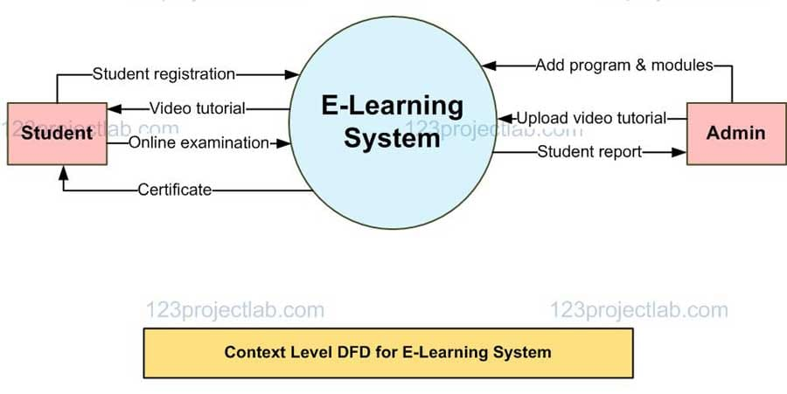

**FIRST LEVEL DATAFLOW DIAGRAM**

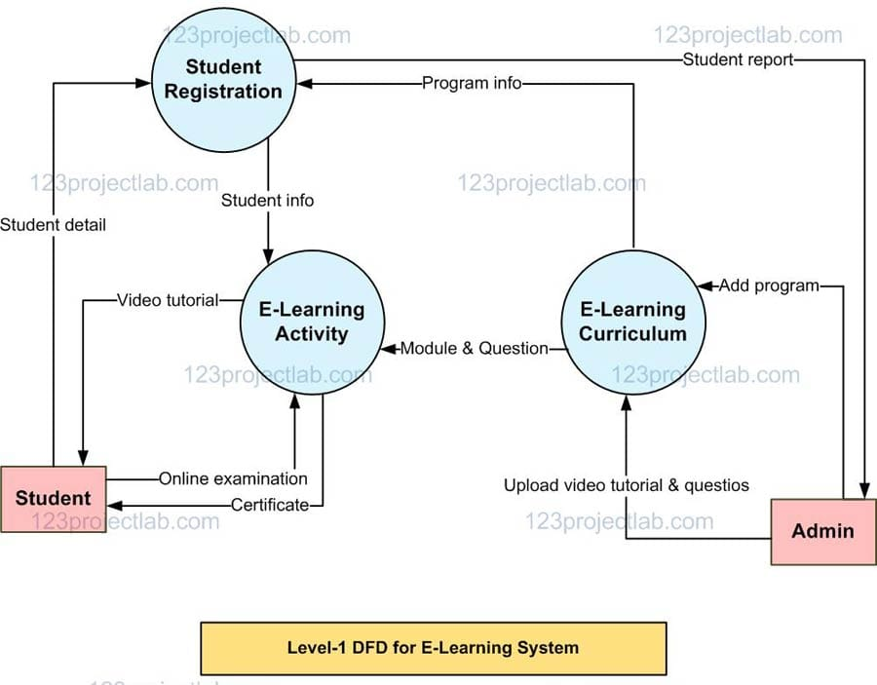

**LEVEL TWO DATAFLOW DIAGRAM**

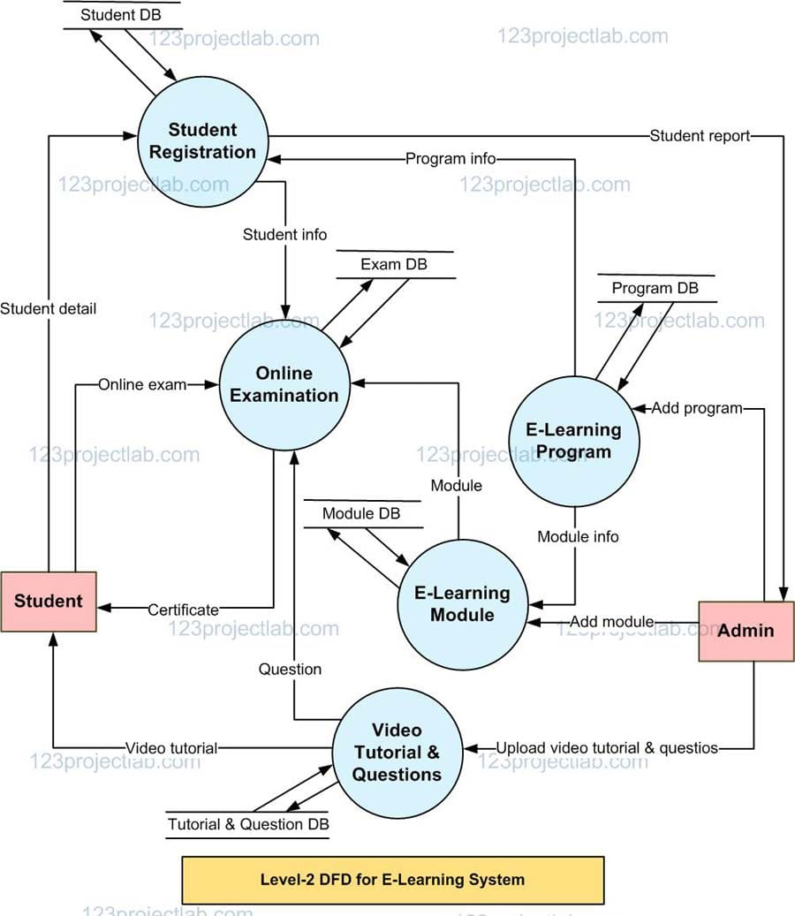

**ARCHITECTURE DIAGRAM**

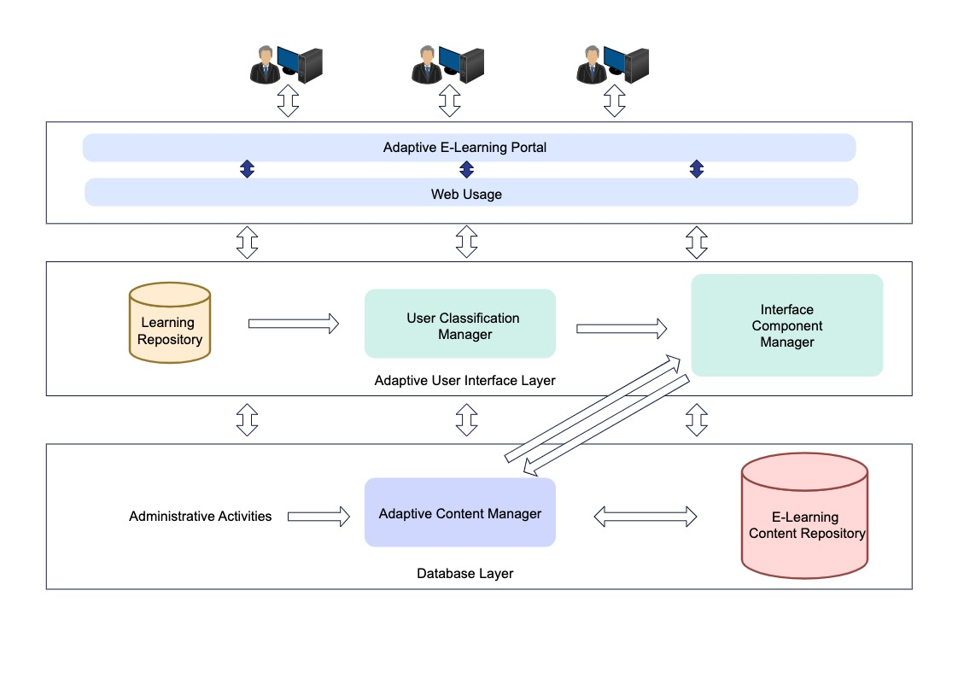

**REFERENCE LINKS**

<https://creately.com/diagram/example/j2azmwx41/course-registration-system-level-0-classic>

<https://youtu.be/bL00UAW_ygE?si=-KX8xgUJrxShzoLJ>

<https://www.slideshare.net/slideshow/uml-diagrams-for-online-course-portal/115353622>

<https://www.slideshare.net/slideshow/course-registration-systemsrs-dfd-structured-chart/250900073>

<https://coggno.com/blog/common-lms-course-assumptions/>

<https://www.slideshare.net/slideshow/online-course-portal-for-campus-with-query-system/14879582>

<https://elearningindustry.com/traditional-learning-vs-online-learning>

<https://youtu.be/WnMQ8HlmeXc?si=9kZwWhhEmwm9V1wj>

<https://youtu.be/6XrL5jXmTwM?si=dTrFbls6xHTiRyE7>

<https://youtu.be/ZTVAs9cNo30?si=66-lBHtQt6jBrsqx>